Add Patient Page
1. Add ability to picture of patient
2. Add to DB PCP, Address, Tel, Fax, Email
3. Add to DB Pharmacy Name, Address , Tel, Fax, Email
4. After you add the patient you should have the button on the top and buttom of the page. They are Cancel, Save, and Save & Chart
Cancel does not but reroutes you back to the patient page
Save - save the information you inputted and reroutes back to patient page
Save & Chart - save the information you inputted and reroutes you to chart page

Patient Page
- Should have status showing . Green is active , completed is red, orange is Inactive
- Default status should be set to Active
- Picture should show up in record as well.
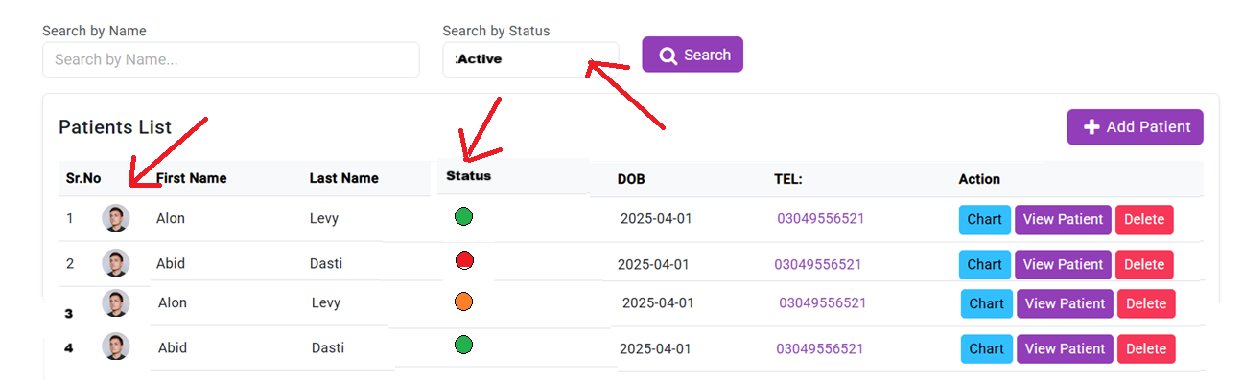

Chart
- The initial wound visit creates the visit correctly; no changes are needed for this step. However, wound name will name wound 1 for the first one and so on based on the number of wounds. These names will be carried over in the next step. You will need a logic for this in your code.
- When creating a Wound visit, you'll now see an additional option: "Save and Copy Wounds from Previous." 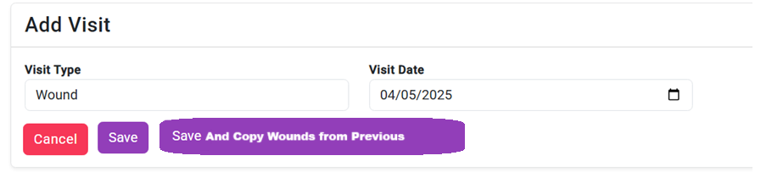
- After saving, you can open the "View Wounds" section and click on "Speed View." Speed View allows you to quickly review each wound and make updates in numerical order. The Speed View interface resembles the "Add Wound" screen with minor differences: the location and wound name fields are automatically populated from the previous visit. You can navigate through wounds easily using the "Save and Next" button. Click "Cancel" to exit Speed View.

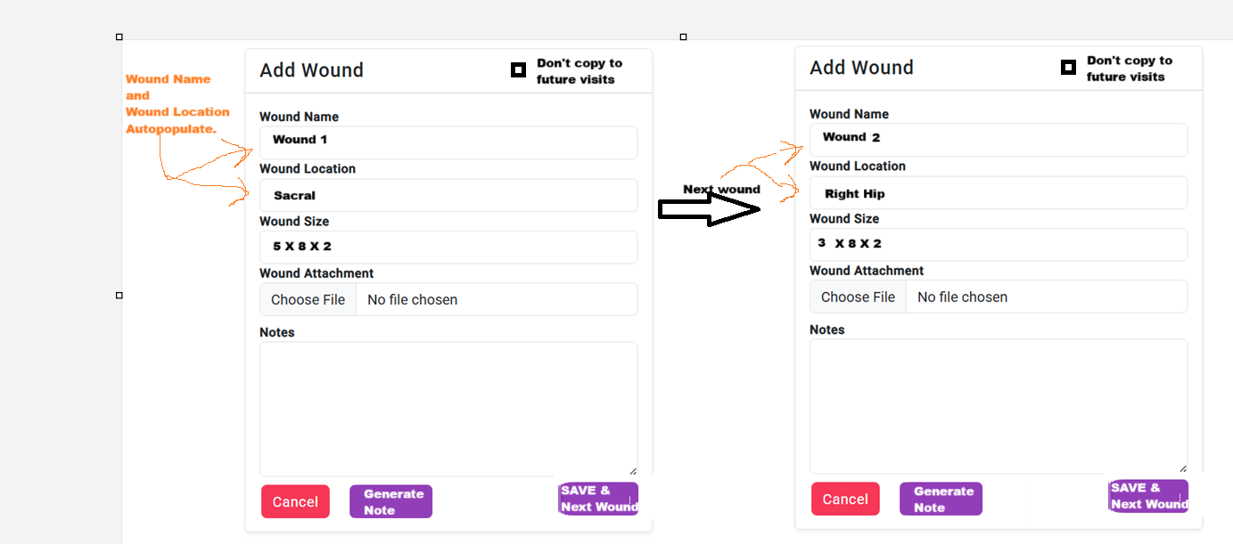
- If you have 3 wounds and you checked “Don’t copy to future visits” . for example if you marked number 3 . then only 1 and 2 will show when copying the wounds. However if you decide to add new wound in a later visit , the wound name will continue to count from the latest one. So it will be called Wound 4. However number 3 will still not show up in future , but number 4 will. So the next visit will have Wound 1, Wound 2, Wound 4. So long as they are opened.

Reports / Settings / Users Roles / Coming soon

